Unit 8 Don't push, please 同步练习
一、用括号内所给动词的适当形式填空。
1. __________ (not, climb) the tree. It’s dangerous.
2. ____________ (not, make) any noise! Your mother is sleeping.
3. ____________ (not, speak) with your mouth full of food and ____________ (be) polite.
4. ____________ ( not, talk) and ____________ (read) aloud.
5. ____________ (not, leave) your homework for tomorrow, Larry.
二、根据图片写单词。
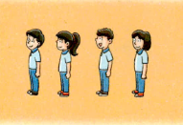

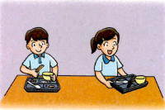

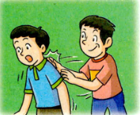



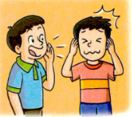

三、翻译下列句子。
1. Don’t shout, please.

2. Don’t talk, Lingling.

3. Don’t push, Wangming.

答案
一、Don’t climb; Don’t make; Don’t speak; be; Don’t talk; read; Don’t leave
二、queue up; clean up; push; talk; shout
三、
请不要大声吵闹。
不要讨论，玲玲。
王明，不要推搡。

